CS460-580 Project#2 Fall 2021

|  |  |
| --- | --- |
| **STUDENT NAME:** |  |
| **Class:** |  |
| Write your answers into existing table cells. Please be sure to note both CS 460 and CS 580 students have problems in both Part 1 and Part 2 | |
|  | |

|  |
| --- |
| **PART 1 - SQL** |
| Use database schema given below labeled “Appendix A” for queries 4 – 7 cs460 (or 4-9 cs580). Write the SQL, and provide the result of each query applied to the given DB state. (Answer must be typed. Handwritten text or pictures are not acceptable.) |
| Ex 4) Write SQL statement to retrieve course name and the department offering the course for all courses taken by student Brown in any fall semester.  ANSWER:  SELECT COURSE.Course_name,  COURSE.Department  FROM (  COURSE  JOIN SECTION USING(Cours_number)  )  JOIN (  GRADE_REPORT  JOIN STUDENT USING(Student_number)  ) USING(Section_identifier)  WHERE STUDENT.Name = 'Brown'  AND SECTION.Semester = 'Fall' |
| Ex 5) Write SQL statement to retrieve the names of all students who took both sections 112 and 119. Show the result of this query applied to the given DB state.  ANSWER:  SELECT STUDENT.Name  FROM (  (  STUDENT  JOIN GRADE_REPORT USING(Student_number)  WHERE GRADE_REPORT.Section_identifier = 112  )  JOIN (  STUDENT  JOIN GRADE_REPORT USING(Student_number)  WHERE GRADE_REPORT.Section_identifier = 119  ) USING(Name)  ) |
| Ex 6) Write SQL statement to retrieve the names of all freshman students majoring in computer science. (Freshman students have class = 1).  ANSWER:  SELECT STUDENT.Name  FROM STUDENT  WHERE Class = 1  AND Major = 'CS' |
| Ex 7) Write SQL statement to do the following: for each section taught by professor Anderson retrieve the course number, semester, year, and names of students who took the section.  ANSWER:  SELECT SECTION.Course_number,  SECTION.Semester,  SECTION.Year,  STUDENT.Name  FROM (  SECTION  JOIN GRADE_REPORT USING(SECTION_identifier)  )  JOIN STUDENT USING(Student_number)  WHERE SECTION.Instructor = 'Anderson' |

CS580 additional PART 1 problems

|  |
| --- |
| Ex 8) Retrieve name and transcript of each sophomore student (sophomore class = 2) majoring in 'CS'. A transcript includes course name, course number, credit hours, semester, year and grade for each course completed by the student.  ANSWER: |
| Ex 9) Write SQL statement to list course names of **the prerequisites of the prerequisites** of CS3380.  ANSWER: |

**PART 2 – Relational Algebra**

Specify the following queries on the Company database schema below labeled “Appendix B”. Queries must be specified in **relational algebra**. For each query provide:

Steps 1-3 for **all students**, step 4 only for CS 580 students

1. Step by step process of deriving result. Use only one relational algebra operator

(discussed in sections 6.1 – 6.5 or 6e textbook, 8.1-8.5 of 7e textbook) at each step.

1. Picture of relational algebra expression tree. The root of the tree is the operator that is performed last. Inner nodes are operators and leaves are database relations (tables).
2. Resulting relation for the database state given Appendix B
3. (This step is for CS580 students only) Corresponding relational algebra expression.

|  |
| --- |
| 1) Retrieve last names of research employees who worked on both ProductY and on ProductZ projects . |
| 2) For each employee list the last name and average number of hours that employee worked on all his/hers projects. |
| 3) Retrieve the names of employees who worked on every project. |
| 4) For each department retrieve the department name, the number of employees working in that department, and average salary of employees in that department. |
| 5) List first and last name, salary, and the name of the department where employee works, and the name of the employee’s supervisor. List employees that do not have a supervisor as well.  NOTE: Manager of the department where employee works is not employee’s supervisor. |

**Appendix A: Database to be used for SQL select problems**

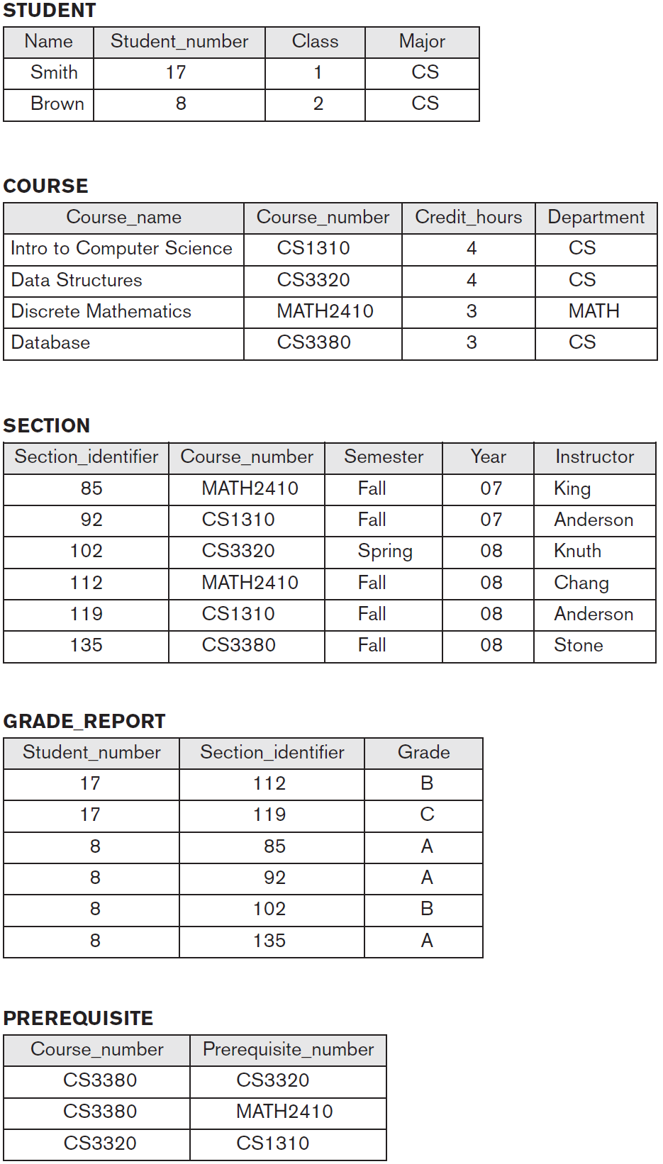

**Appendix B: Database to be used for relational algebra problems**

